Preyasi Gaur

705704939

CS M146

Problem Set 2

**1 Perceptron**

1. OR  
   Here we have constructed a truth table for the OR function:

| x1 | x2 | y |
| --- | --- | --- |
| 1 | 1 | 1 |
| 0 | 1 | 1 |
| 1 | 0 | 1 |
| 0 | 0 | 0 |

Drawing from this truth table we can see that the OR function is True (+1) when one or more inputs is 1, and returns False(-1) if both the inputs are 0. Drawing the graph, we can see that the function is clearly linearly separable.

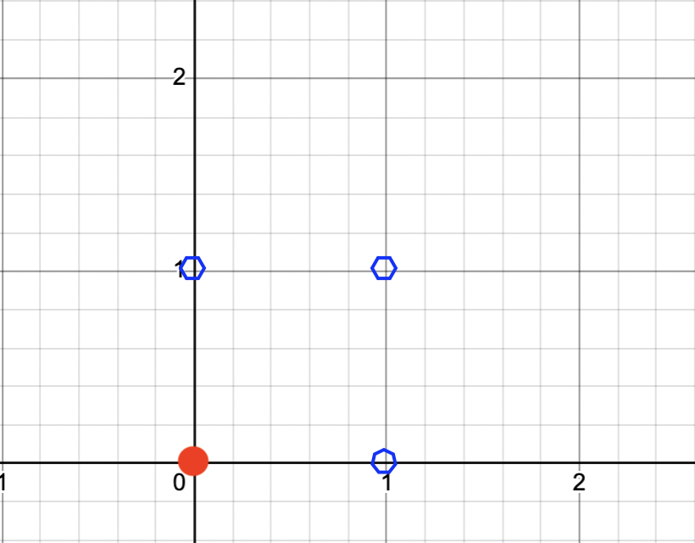  
Thus, a possible perceptron model is   
θ = -10 + 20 $x_{1}$ + 20 $x_{2}$

If $x_{1}$ and $x_{2}$ are both 0, θ = -10 ⇒ the output is (-1) False

If $x_{1}$ = 1 and $x_{2}$ = 0, θ = 10 ⇒ the output is (+1) True

If $x_{1}$ = 0 and $x_{2}$ = 1, θ = 10 ⇒ the output is (+1) True

If $x_{1}$ and $x_{2}$ are both 1, θ = 30 ⇒ the output is (+1) True

However, this perceptron model is not unique and we can define another model, with different weights like:

θ = -1 + 10 $x_{1}$ + 10 $x_{2}$

If $x_{1}$ and $x_{2}$ are both 0, θ = -1 ⇒ the output is (-1) False

If $x_{1}$ = 1 and $x_{2}$ = 0, θ = 9 ⇒ the output is (+1) True

If $x_{1}$ = 0 and $x_{2}$ = 1, θ = 9 ⇒ the output is (+1) True

If $x_{1}$ and $x_{2}$ are both 1, θ = 19 ⇒ the output is (+1) True

Both of these perceptron models represent the OR function, but as they have different weights, they represent different hyperplanes.

1. XOR  
   It is not possible to design a perceptron model for XOR as the function is not linearly separable, and thus cannot be modeled using a single hyperplane. Notice the outputs for the XOR function:

| x1 | x2 | y |
| --- | --- | --- |
| 1 | 1 | 0 |
| 0 | 1 | 1 |
| 1 | 0 | 1 |
| 0 | 0 | 0 |

Plotting this outcome we see the result to be like

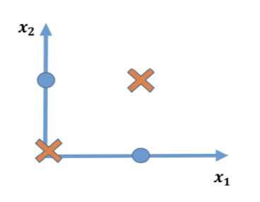

Thus, there is no way to linearly classify the data and a perceptron is not possible.

**2 Logistic Regression**

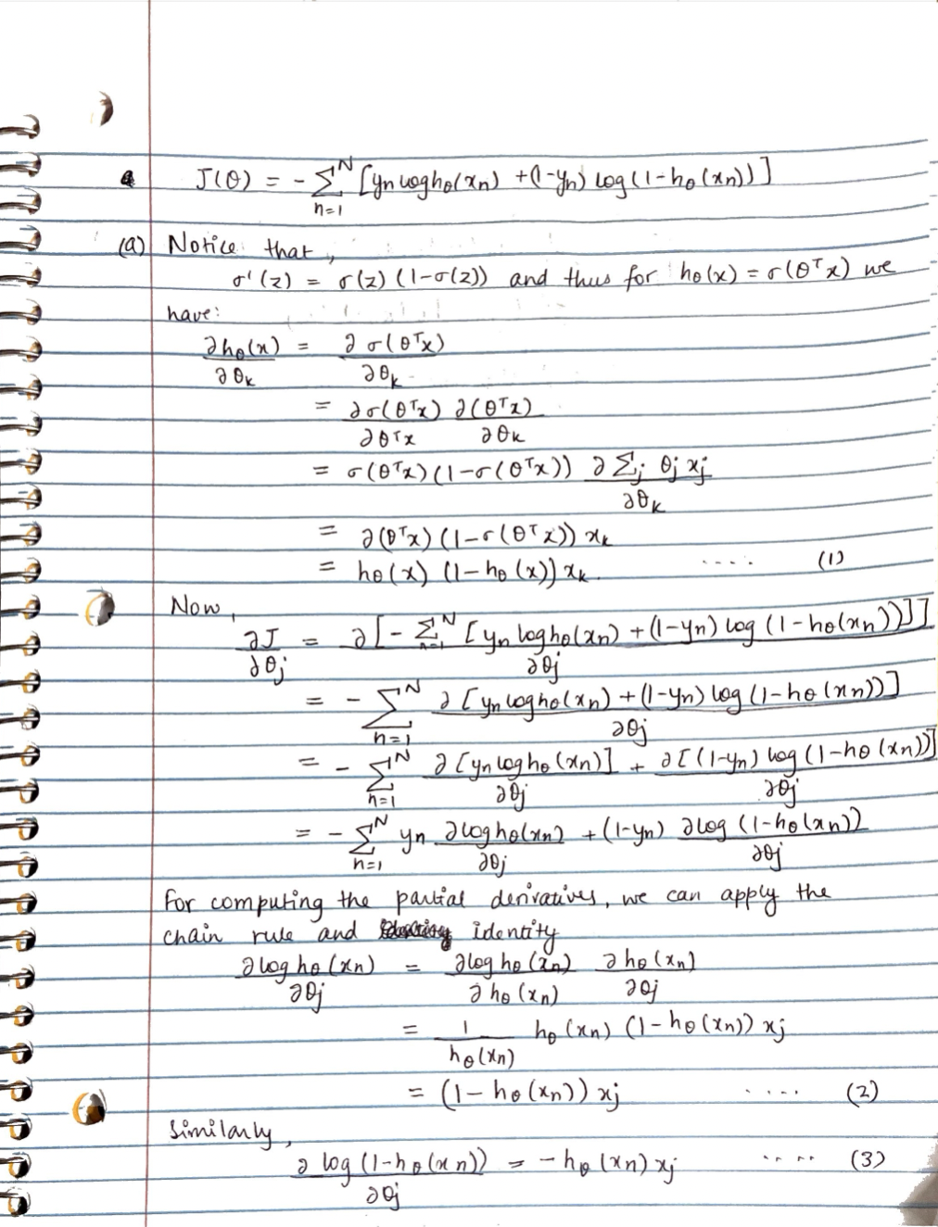

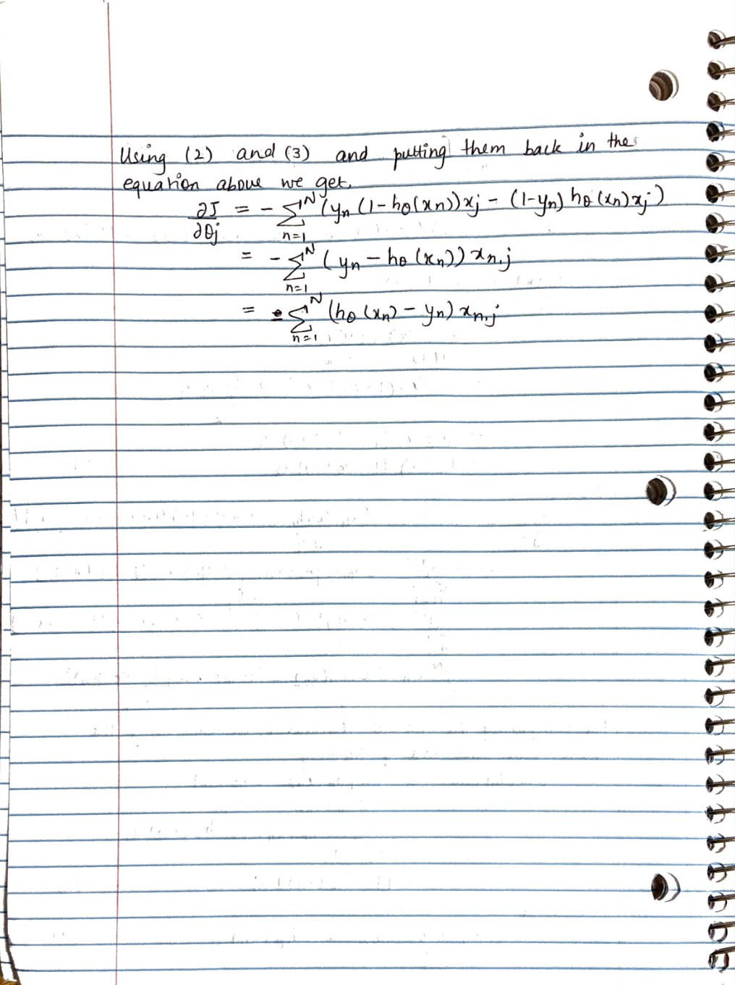

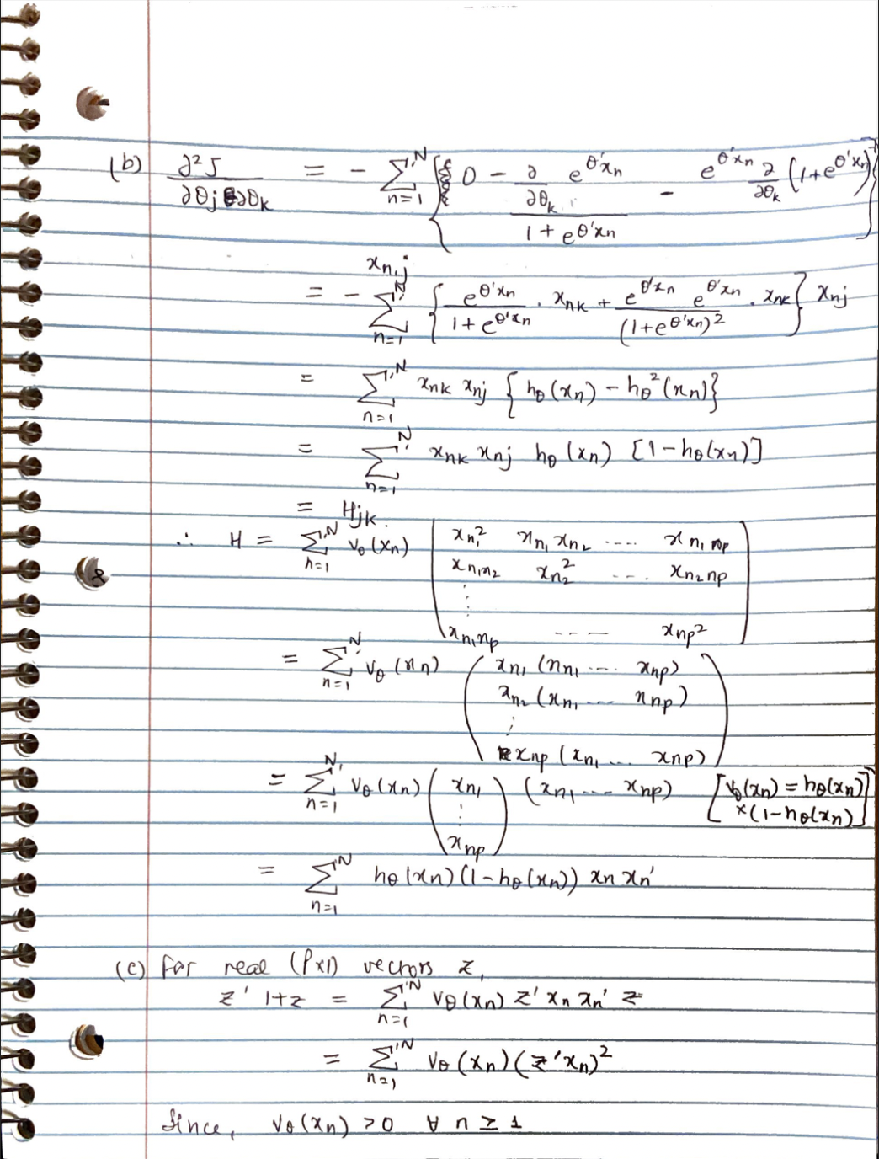



**3 Maximum Likelihood Estimation**

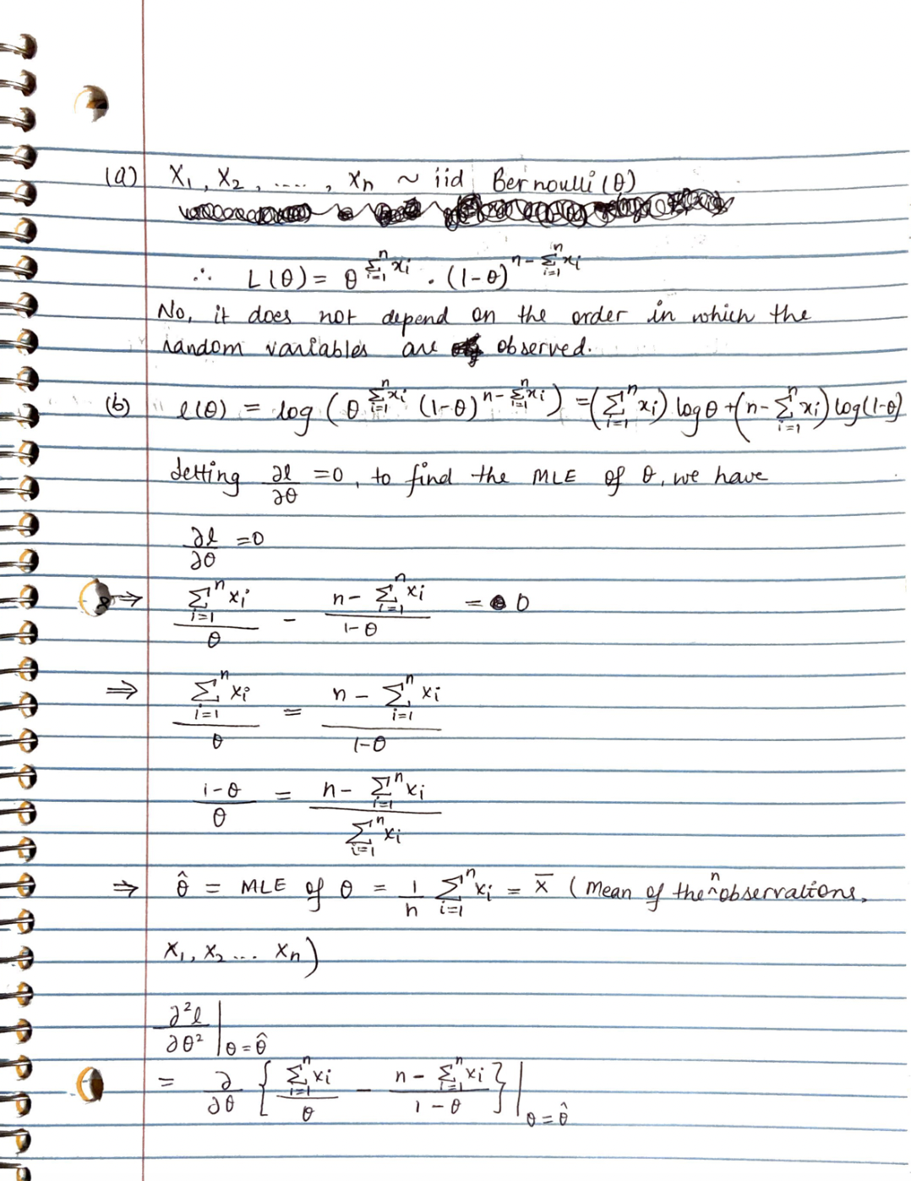

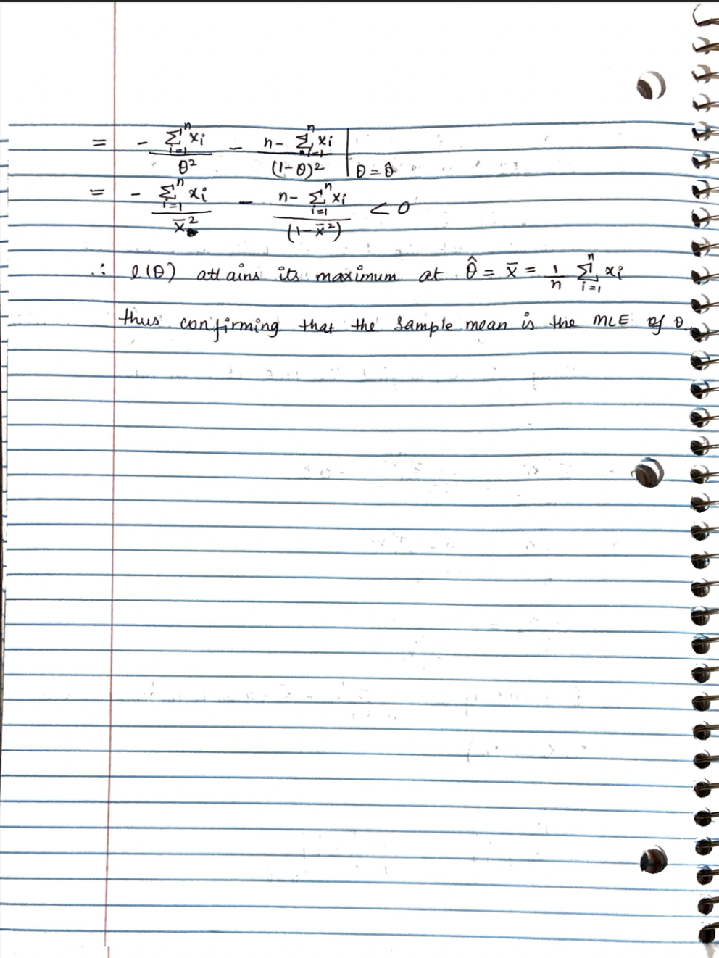

(c)   
 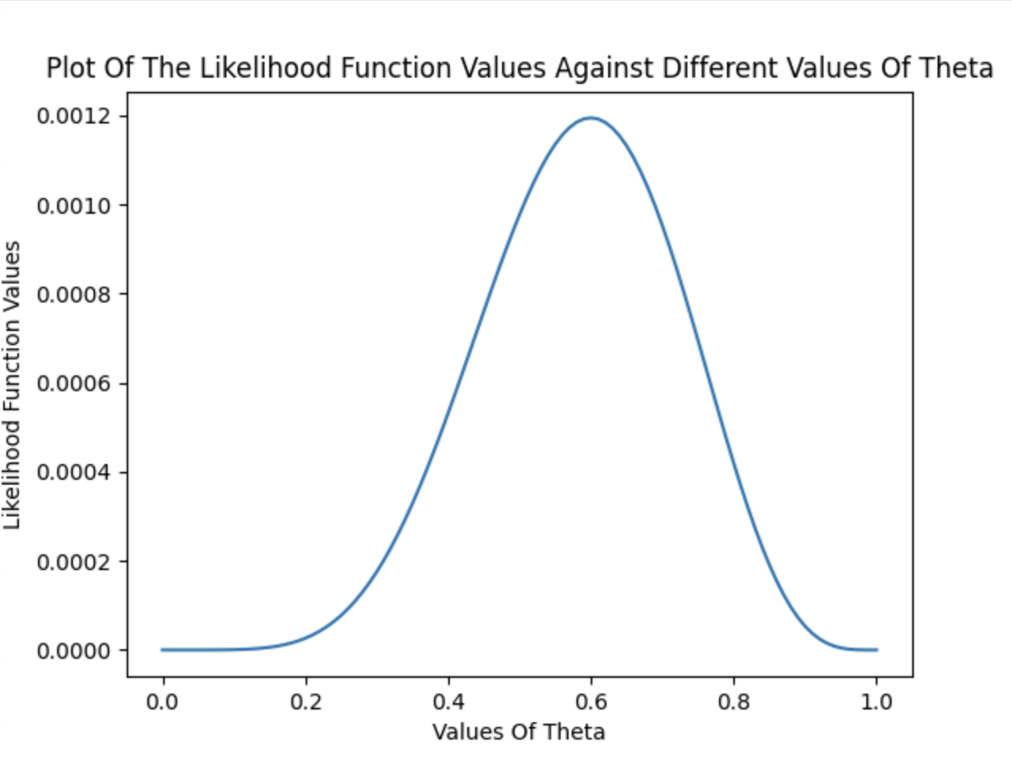

(d)  
 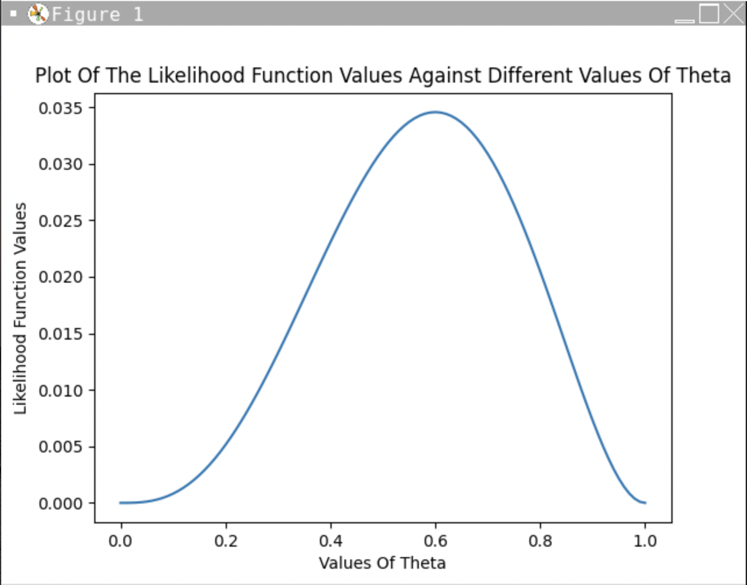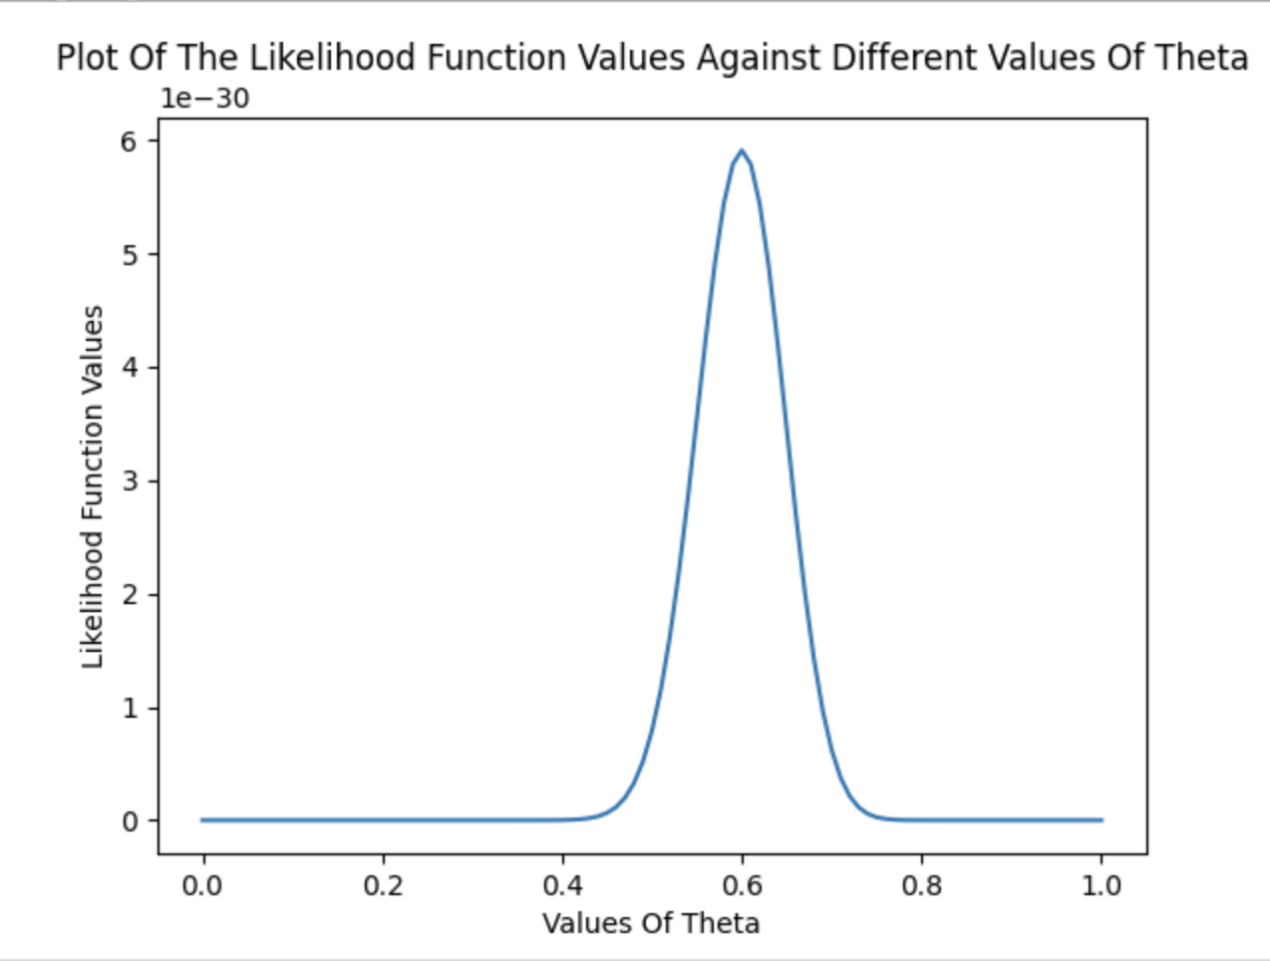

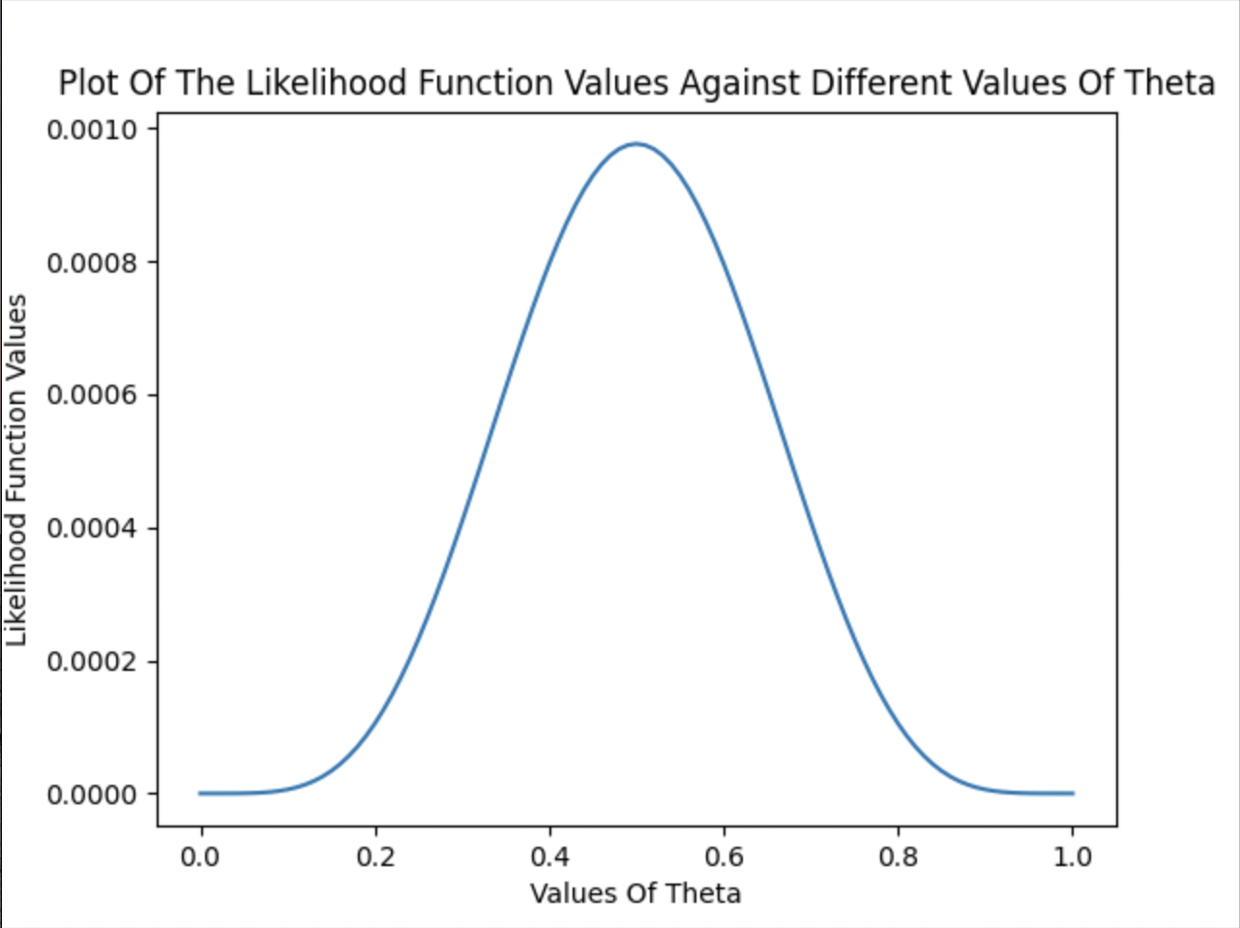

**4 Implementation: Polynomial Regression**

1. Neither data shows a linear relationship. A simple linear regression would be a poor predictor; a polynomial regression would be a better predictor.

Train Data:  
  
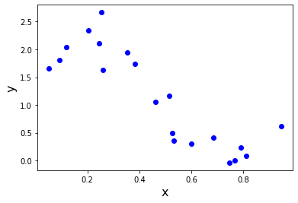

Test Data:  
 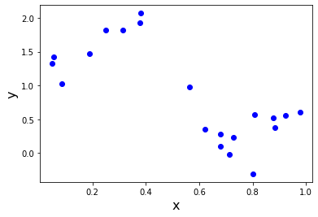

1. 
2. 
3. Computing J(θ):  
   y_predicted = self.predict(X)  
   n,d = X.shape  
   cost = 0

for i in range(len(X)):

cost += (y_predicted.flat[i] - y[i]) ** 2

1. • Implement the closed-form solution PolynomialRegression.fit(...)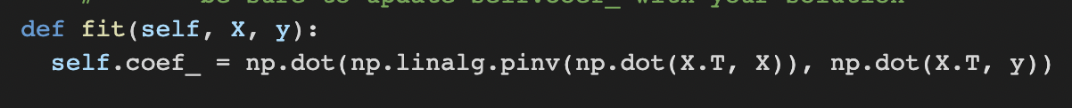

• The closed-form solution gives the exact solution in just one calculation, without using an iterative algorithm like gradient descent. But, the closed form can computationally be expensive, especially for large datasets. In our case, the closed form solution is faster as our dataset is small. Thus, the iterative algorithm of gradient descent (GD) is more expensive than matrix-multiplication and matrix-inverse calculations.

(f)  
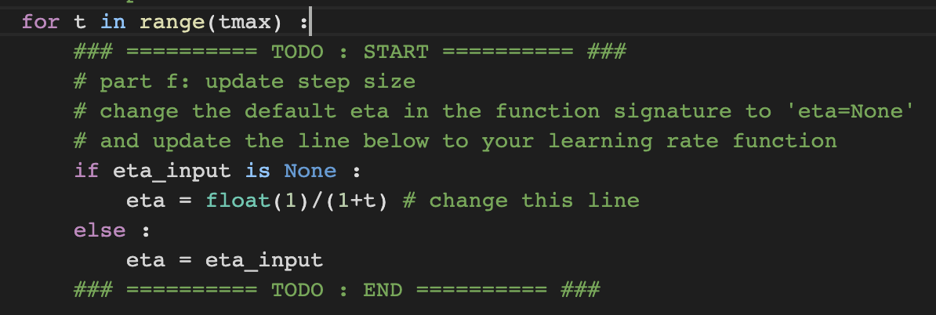

(g)

(h) RMSE has multiple advantages over using the cost function J(θ). Some of them are:   
• Normalization: RMSE is normalized by the number of instances N, making it easier to compare the performance of different models trained on different datasets.  
• Sensitivity to error: RMSE is sensitive to errors made by the model, meaning that large errors have more impact on the score than small errors. This property is desirable in many cases, as we tend to care more about accurately predicting larger errors.   
• Intuitive interpretation: RMSE is expressed in the same units as the target variable, which makes it easy to interpret. This is not the case for J(θ).  
• Optimization: RMSE is a convex function of the parameters, which means that it is easier to optimize than J(θ).  
 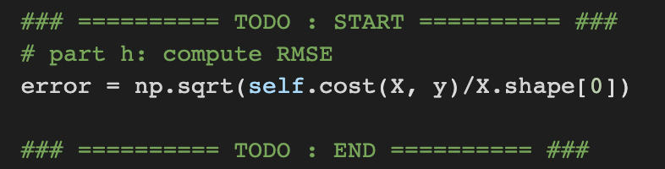

(h)



(i) The minimum test error will be at polynomial of degree 5. There will be underfitting to the left and overfitting to the right